# Bug 3 – Debugging Log

Hypothesis 1:

|  |  |
| --- | --- |
| Hypothesis | Win percentage is different due to SPADE not being included in rolls |
| Prediction | Playing a large number of games will result in an incorrect win percentage |
| Experiment | Run game and observe |
| Observation | Prediction was correct |
| Conclusion | Due to SPADE not appearing in dice rolls the percentage is skewed and therefore must resolve bug 5 |

Bug Resolution:

To resolve the bug we need to resolve bug 5(see bug 5 Debugging for results), applying this fix is demonstrated in the before and after screenshots:

Before:

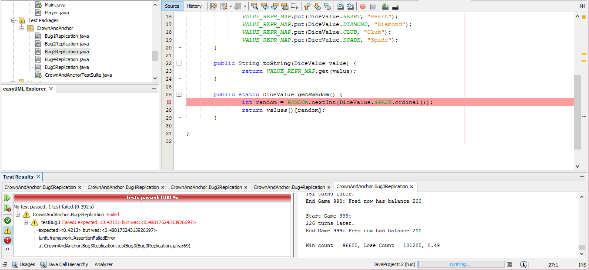

After:

